**Sports car** probability question. All probabilities add up to 1.00. Subtract to find missing probability.

Equation is P(A u B) = P(A) + P(B) – P(A n B) = .52 = 52%

**P(A n B)** = point of intersection of A and B

Probability of red manual car = P(R / M) = $\frac{P\left(R n M\right)}{P\left(M\right)}=\frac{.18}{.15+.07+.15+ .18}$ = .327 = 33%

**Women in college. Find probability of women in college**

P(F n C)/P(C) = $\frac{\left(.75\right)\left(.85\right)}{\left(.75*.85\right)+\left(.25\right)\left(.78\right)}= .765 or 76.5\%$**Part B. P(attended college) Denominator from Part A**

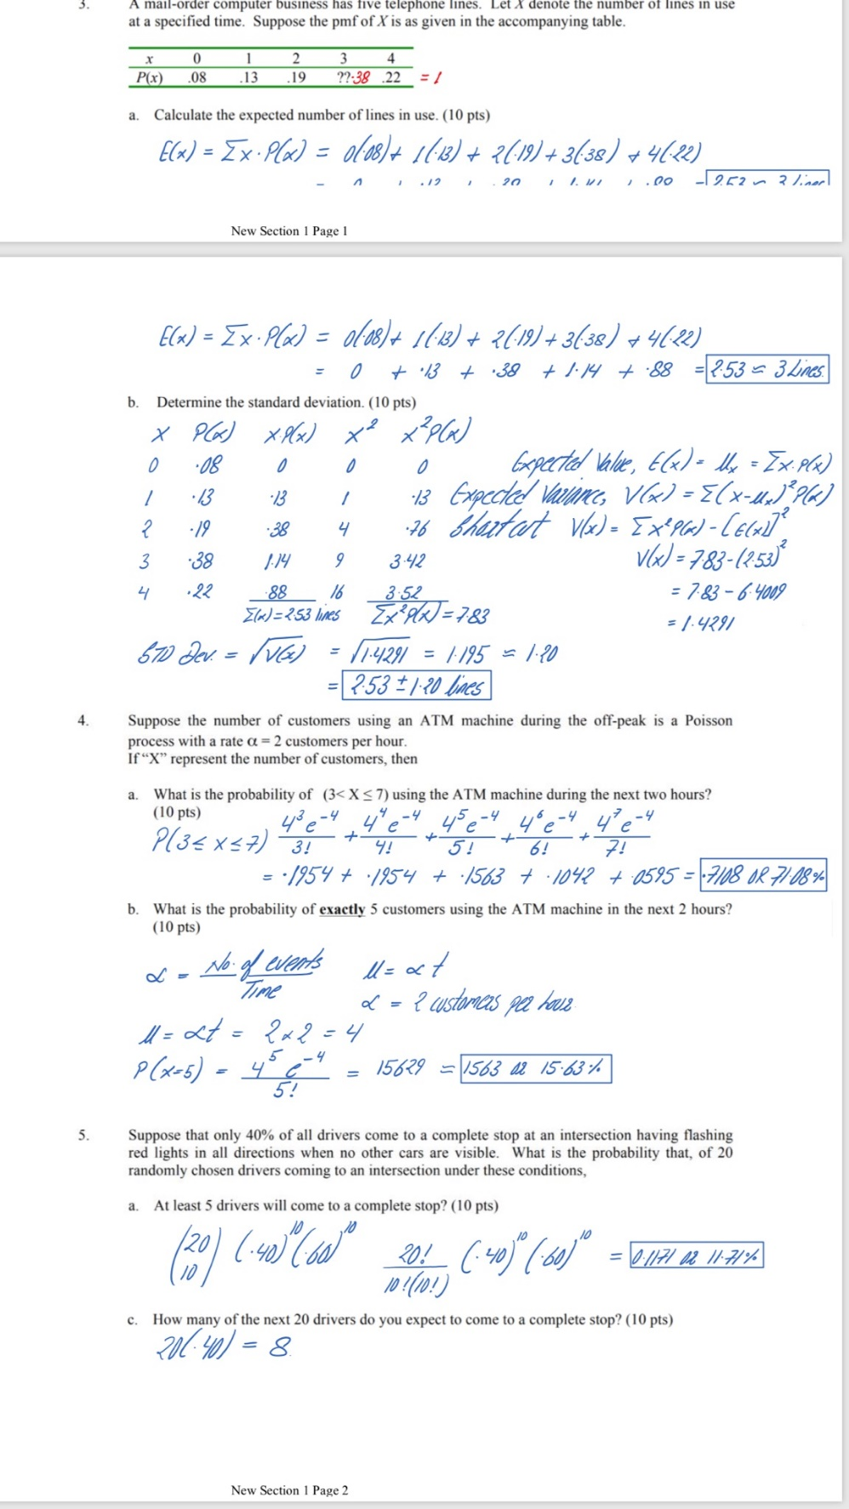

For P(3 <= x <= 7) $\frac{〖{(Μ〗}^{x}*e^{-Μ})}{x!}$ = $(4^{3}*e^{-4}$)/3!)) + ($4^{4}*e^{-4})/4!$)) + …

$Μ=α*t$. To Find exactly x amount of customers, just do one term of function from part a

**5**Equation for drivers at stop light

n = # of trials p = probability of success q = |1-p| x =number of drivers => $(\frac{n!}{x!*\left(n-x\right)! }*\left(p^{x}\right)*\left(q^{n-x}\right)$

40% of drivers come to a stop. Of 20 randomly chosen drivers, what is probability that: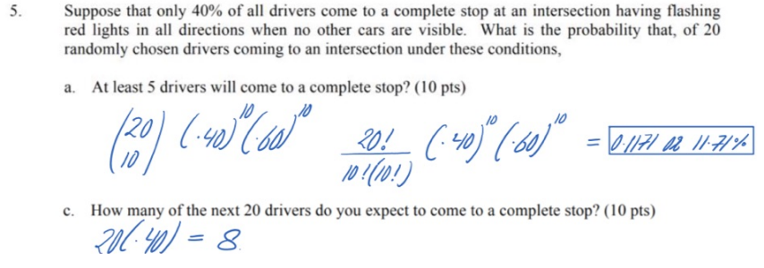

* **Shortcut for standard deviation**
* **Take square root of this :**
$S^{2}=\frac{\sum{x^{2}}-\frac{{\left(\sum{x}\right)}^{2}}{n}}{n-1}$

$S=\sqrt{S^{2}}$

* **Variance , S2 =**  Variance for population : $σ^{2}=\frac{\sum{{\left(x-u\right)}^{2}}}{N}$
* Chebyshev’s Rule
* Minimal Spread = $1 -\frac{1}{k^{2}}$
* K = no. of + and – std. dev from the mean
* **Mean $\overline{x}$ or $u$** 
  + 1000,8,7,9,4 => $\overline{x}= 6.6$
$\overline{x}= 205.6$

* **Median $\tilde{x}$** (if n is odd, then $\tilde{x}$ is the middle number)
  + $\overline{x}$ = $\frac{∑x}{n} or M=\frac{∑x}{N}$
 $\tilde{x}$

 + 4,7,8,9,1000
    - (8+9) / 2 = 8.5

When you have normal distribution, then $\overline{x}$ = $\tilde{x}$

When $\overline{x}>\tilde{x }$ skewed to right (Mean greater than median)

* "Positively skewed"

When $\overline{x}<\overline{x}$ skewed to left (Mean less than median)

* "Negatively skewed"
* **How to find any percentile**
* Find 38th percentile, n = 11.

|  |  |  |  |  |  |  |  |  |  |  |
| --- | --- | --- | --- | --- | --- | --- | --- | --- | --- | --- |
| 16.4 | 16.4 | 28.2 | 31.5 | 34.1 | 36.6 | 40.4 | 45 | 76.7 | 77.7 | 109.9 |

$\tilde{x}= 36.6$

* P% = (P/100)*n = (.38)(11)
* = 4.18
* Index(4) + .18(Index(4+1)-Index(4))

$=31.5 + .18\left(34.1-31.5\right)=31.96$